Additional Exercises #6:



(a)

Tp↑0 ={Ø}

Tp↑1 = { q(a), r(b, c) }

Tp↑2 = { q(a), r(b, c), q(b) }

Tp↑⍵ = { q(a), r(b, c), q(b) }





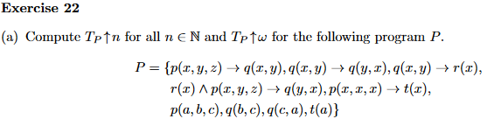

Tp↑0 ={Ø}

Tp↑1 ={ p(a, b, c), q(b, c), q(c, a), t(a) }

Tp↑2 ={ p(a, b, c), q(b, c), q(c, a), t(a) }

(uncompleted)

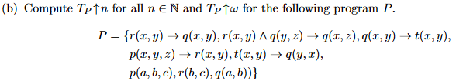

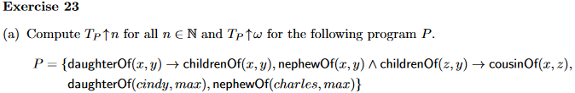

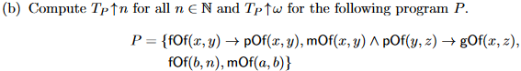





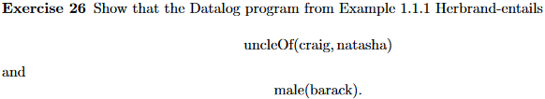

Tp↑0 ={Ø}

Tp↑1 = Tp↑0 ∪ {motherOf(marian, michelle), brotherOf(craig, michelle), motherOf(ann, barack), fatherOf(barack, malia), motherOf(michelle, malia), fatherOf(barack, natasha), motherOf(michelle, natasha), male(craig), female(natasha)}

Tp↑2 = Tp↑1 ∪ { **male(barack)**, parentOf(marian, michelle), parentOf(ann, barack), parentOf(barack, malia), parentOf(michelle, malia), parentOf(barack, natasha), parentOf(michelle, natasha), }

Tp↑2 = Tp↑3 ∪ { **uncleOf(craig, michelle)**, ... }

P⊨HA We know Herbrand-entails because uncleOf(craig, natasha) and male(barack) are included in Tp↑𝝎

Answer on board:

To get uOf(c,n):

Fact 7 together with fact 11 yield

pof(m,n) (F1)

Fact (2) and (f1) together with rule 13 yields

uOf(c,n) as desired

To get m(b)

Fact(6) together with rule(14) yields m(b) as desired